https://code.visualstudio.com/docs/python/python-tutorial

Linux/macOS: open a Terminal Window and type the following command:
python3 --version
Windows: open a command prompt and run the following command:
py -3 --version

Command Palette (Ctrl+Shift+P), start typing the Python: Select Interpreter

This modify the python path parameter in the workspace

We can copy the path in the user setting also

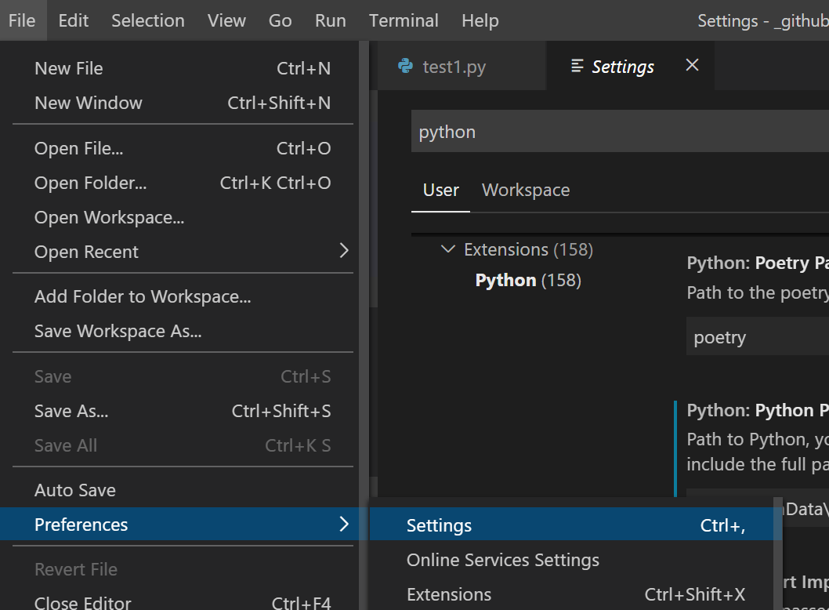

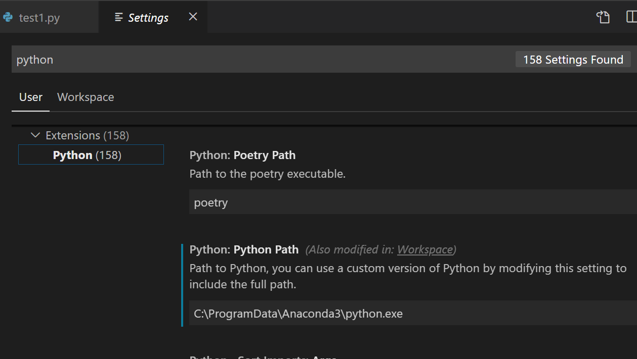

A best practice among Python developers is to avoid installing packages into a global interpreter environment. You instead use a project-specific virtual environment that contains a copy of a global interpreter. Once you activate that environment, any packages you then install are isolated from other environments. Such isolation reduces many complications that can arise from conflicting package versions. To create a virtual environment and install the required packages, enter the following commands as appropriate for your operating system

https://code.visualstudio.com/docs/python/environments#_global-virtual-and-conda-environments

python -m venv .venvluc

